IT457 -Cloud Computing
DNS Hands-on

Exercise 1: Forward & Reverse Record Queries
In this exercise, you will query specific DNS record types to observe how human-readable hostnames map to IPv4 addresses, canonical aliases, and reverse pointer mappings.
1.1: Query IPv4 Mapping (A Record) and Subdomain Canonical Names (CNAME)
- Run a standard forward DNS lookup to retrieve the IPv4 address (A record) for wikipedia.org:

dig wikipedia.org A
- Run the query with the concise output flag:

dig wikipedia.org A +short
3. Inspect a subdomain to locate a Canonical Name (CNAME) record:
Bash

dig www.github.com CNAME

Information to note:
- Locate the ANSWER SECTION in the standard dig output.
- Note the IP address returned for wikipedia.org.
- Observe how [www.github.com](https://www.github.com) aliases to an underlying target hostname.
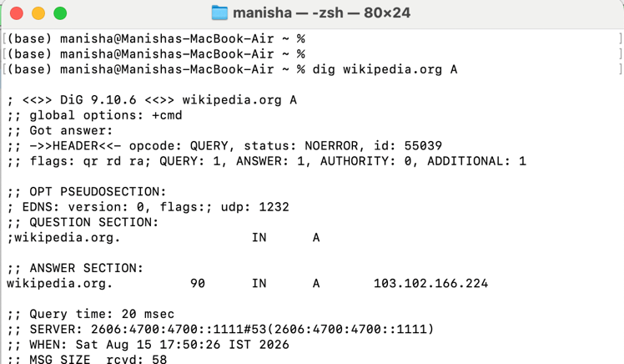
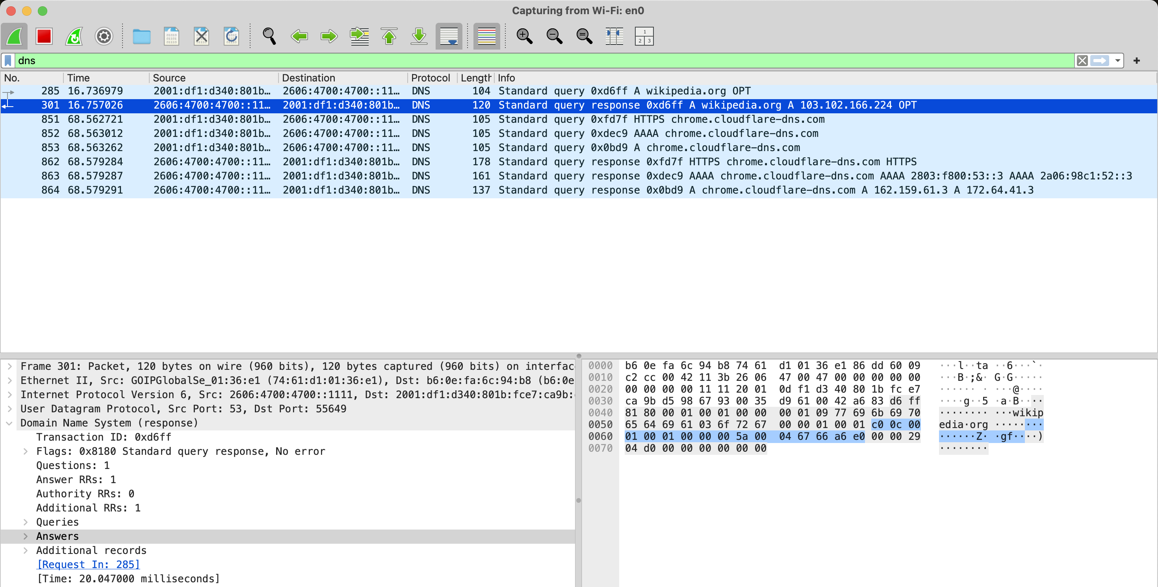
Search DNS
1.2: Reverse IP Address Lookup (PTR Record)
Query DNS using an IPv4 address to determine its associated hostname via Pointer (PTR) records:

dig -x 8.8.8.8 +short
Information to note:
Records displayed in the output
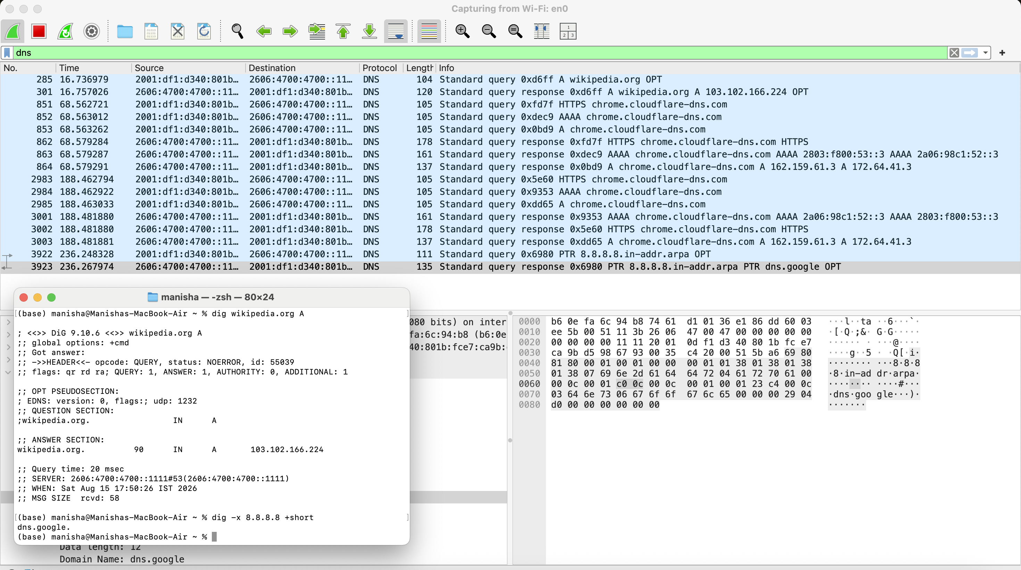

Exercise 2: Tracing Iterative Resolution Hierarchy
In this exercise, you will trace a DNS resolution from the global Root Servers (.) down to the authoritative nameservers for a target domain (aws.amazon.com).
2.1: Perform an Iterative Trace
Execute dig with the +trace flag to simulate recursive resolver behavior:

dig aws.amazon.com +trace

Step-by-Step Resolution Analysis
Observe the four sequential stages in the trace output:
- Root Nameservers (.): Queries root servers to find .com TLD servers.
- Top-Level Domain (.com): Queries TLD servers to locate authoritative servers for amazon.com.
- Authoritative Domain Servers (amazon.com): Obtains authoritative nameserver records
- Final Record Answer (aws.amazon.com): Receives the final CNAME / A record mapping.
Information to Note:
Root servers, TLD servers and Authoritative servers names
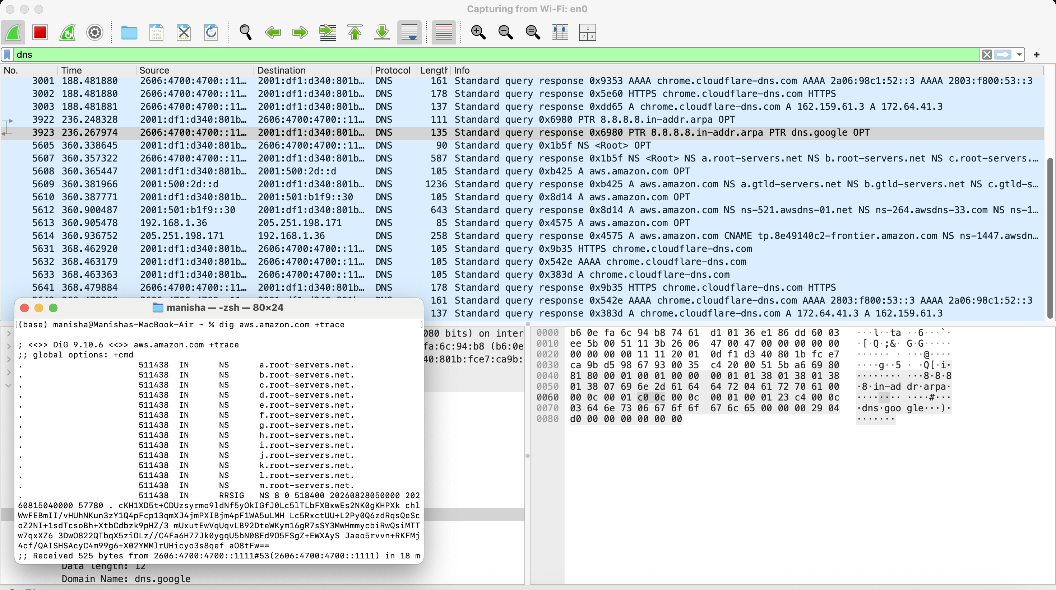

Exercise 3: TTL Caching Mechanics and Local Resolver Overrides
In this exercise, you will observe DNS Time-To-Live (TTL) countdown behavior and test local OS hostfile resolution overrides.

Task 3.1: Observe TTL Decrement in Resolver Cache
- Execute a dig query for example.com:

dig example.com
- Locate the integer in the 2nd column of the ANSWER SECTION (e.g., 86400). This represents the TTL value in seconds.
- Re-run the exact same command immediately:

dig example.com
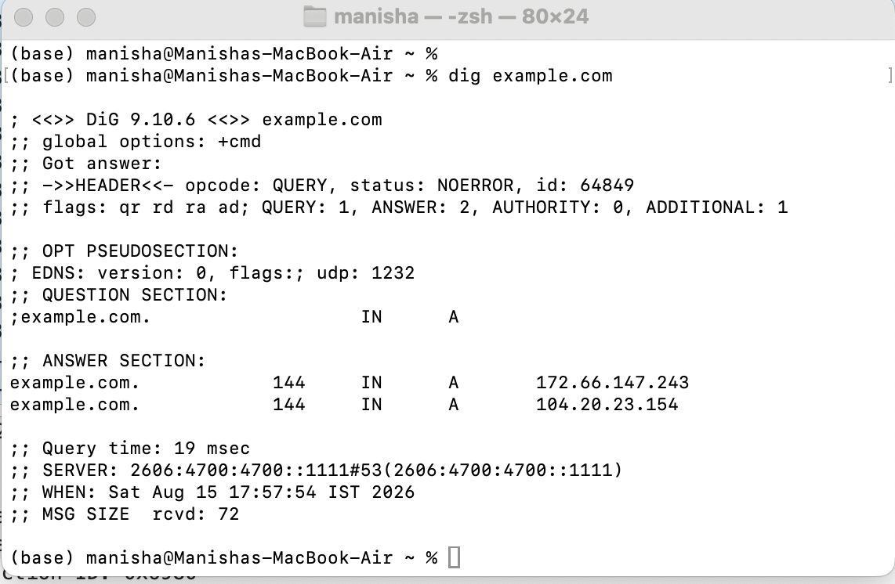
4. Observation: Note that the TTL value has decreased, confirming that your local/upstream recursive resolver is serving the record directly from its cache.

Exercise 3: Mail Exchange (MX) and Text (TXT) Metadata Records
In this exercise, you will inspect secondary DNS record types essential for mail routing, domain ownership verification, and security policies (SPF/DKIM).
4.1: Query Mail Exchange Records

dig google.com MX +short
Note the preference/priority numbers preceding each mail server address.
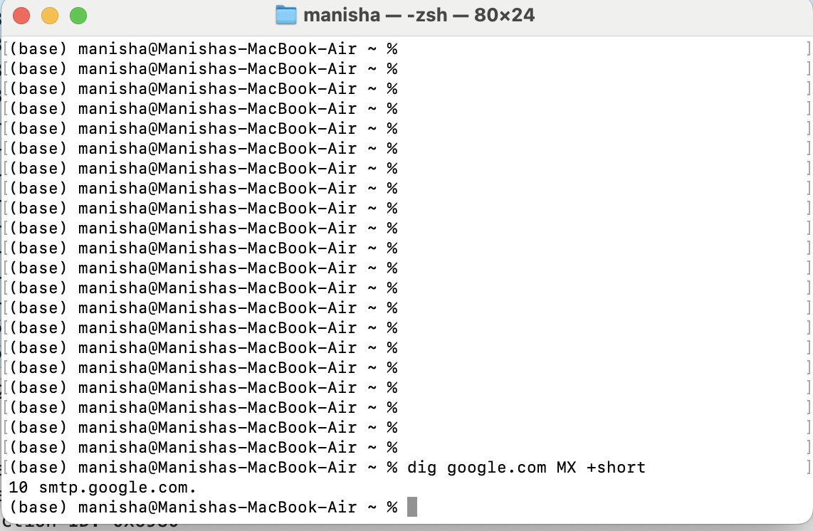
4.2 Query Text (TXT) Records Bash

dig google.com TXT +short
Observe verification strings, Sender Policy Framework (SPF) records, and domain ownership tokens.

Exercise 4: DHCP
Step 1: For windows
Command: ipconfig /release
This will release your existing IP
Command: ipconfig /renew
This will assign new IP using DHCP

For Mac
Command: sudo ipconfig set en0 DHCP
This requests a new IP via DHCP
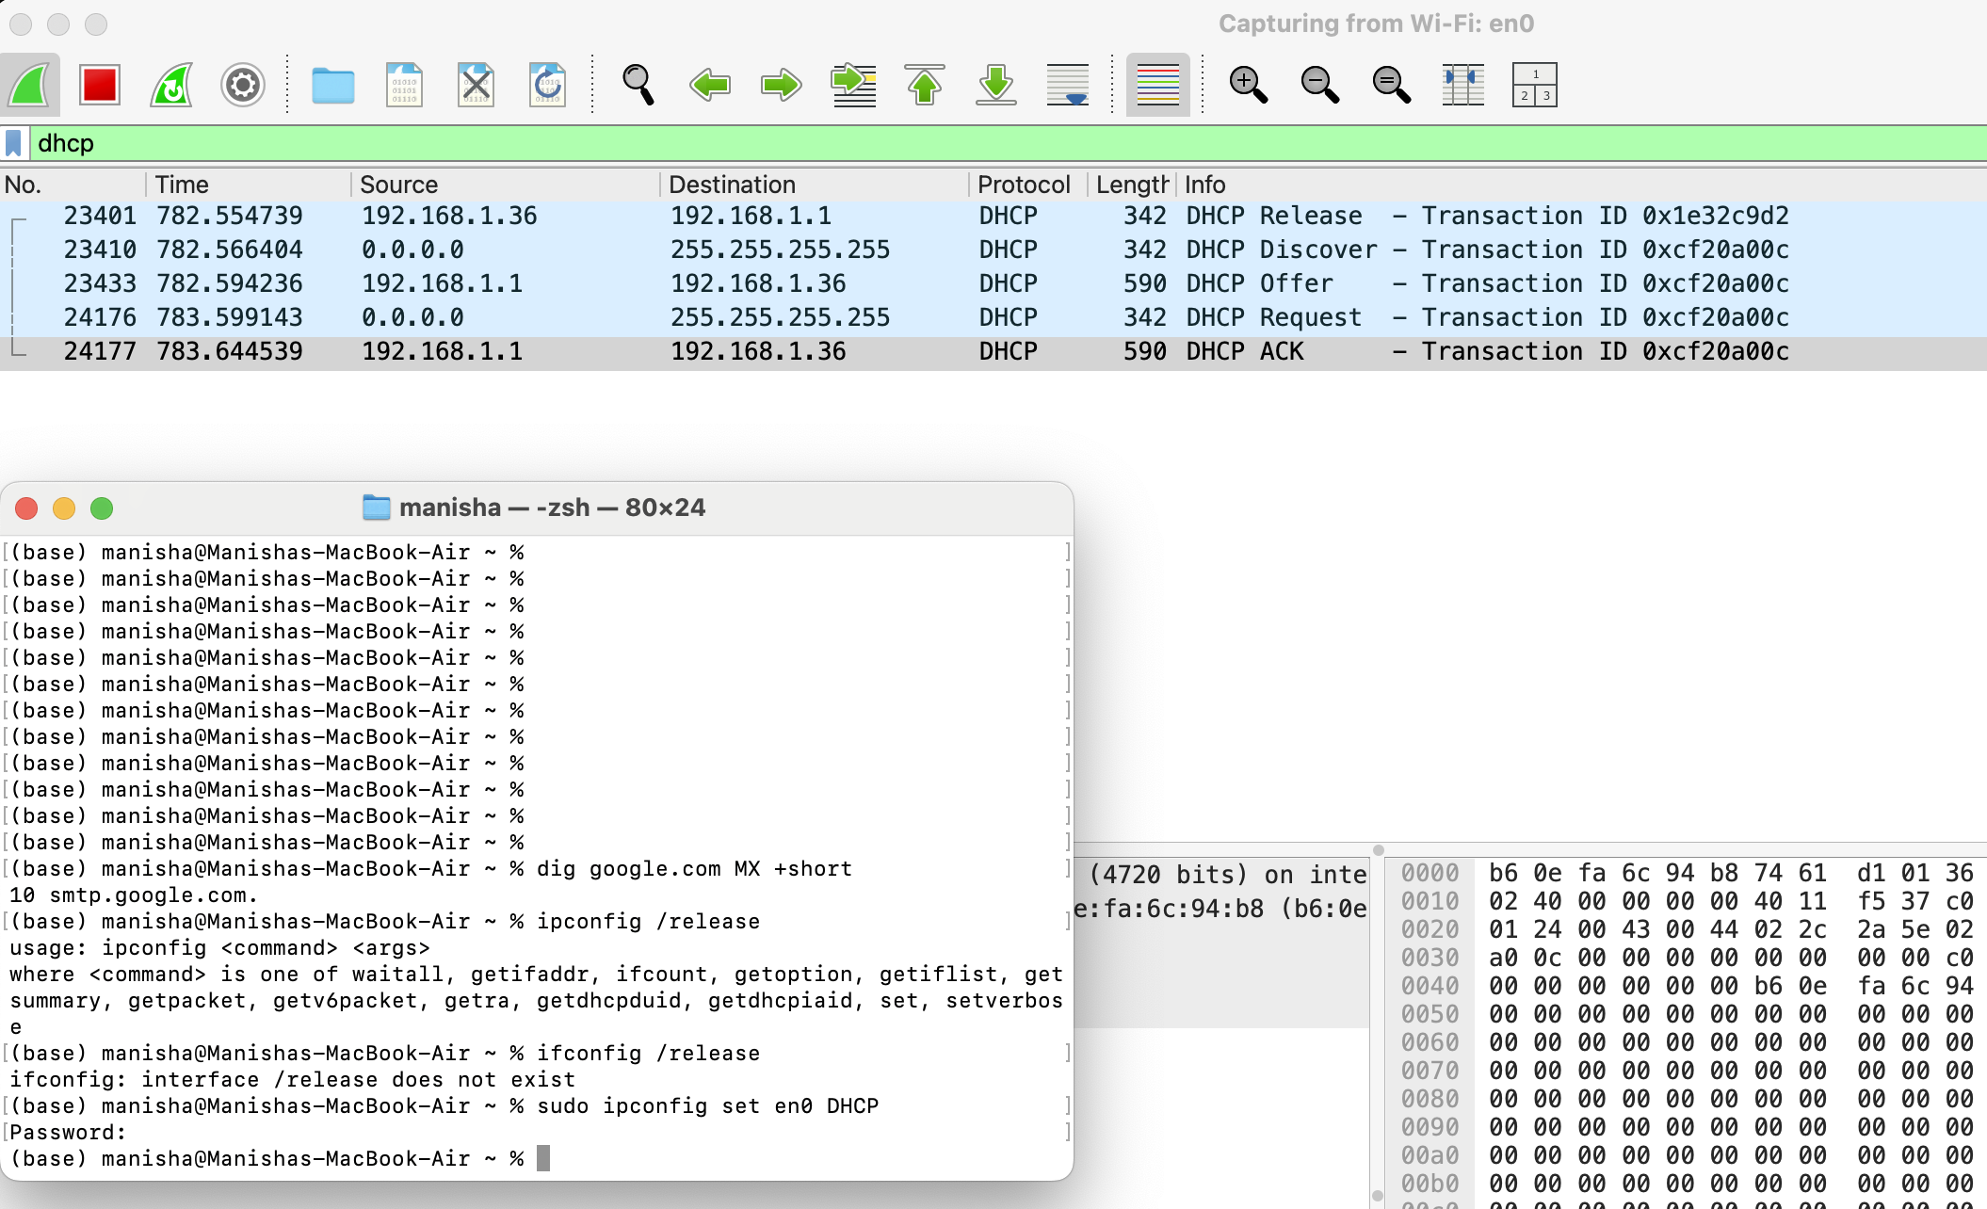

Lab Assessment Questions

Section A: Output Analysis
- A network engineer executes dig dev.example.com and receives NXDOMAIN in the header section. What does this response code indicate?
- If an MX record query returns both 10 mail1.example.com and 20 mail2.example.com, which server will a sending mail transfer agent (MTA) attempt to deliver to first? Explain why.
- Why does running ping app.local use the /etc/hosts file entry, whereas dig app.local ignores it?

Section B: Practical Troubleshooting Scenario
Scenario: A company updates its web server IP address from 192.0.2.10 to
198.51.100.50. The A record TTL was set to 86400seconds. Users in Branch Office A can access the new site immediately, while users in Branch Office B are still routed to the old IP address.
- What is causing the discrepancy between the two branch offices?
- How many hours will Branch Office B take to update automatically?
- Which dig command can an engineer run to bypass local caching and query the domain's authoritative nameserver directly?

